AIR QUALITY INDEX METER SYSTEM



By
Huzaifa Shahbaz
21-CE-009

Aqsa Shah
21-CE-039

Final Year Project Report

Department of Computer Engineering
HITEC University, Taxila

Fall 2021

Declaration
We hereby declare that this project neither as a whole nor as a part there of has been copied out from any source. It is further declared that we have developed this project and the accompanied report entirely on the basis of our personal efforts made under the sincere guidance of our supervisor. No portion of the work presented in this report has been submitted in the support of any other degree or qualification of this or any other University or Institute of learning. If any violation is found in this FYP report, we will be liable to be punished under the plagiarism rules of HEC.

Signature:_________________
Name: Huzaifa Shahbaz

Signature:____________
Name: Aqsa Shah

HITEC University, Taxila

Fall 2021

Dedication

This project is dedicated to our beloved parents and supervisors, whose continued support, encouragement, and guidance have helped us through our academic journey. Faith in our abilities has always made us motivated. We shall equally thank our esteemed department teachers for giving us important knowledge and direction to us during our academic progress. Their dedication and mentorship were vital for shaping our learning experience.


Department of Computer Engineering HITEC University, Taxila
AIR QUALITY INDEX METER SYSTEM
Presented by
Name Roll No
Huzaifa Shahbaz 21-CE-009
Aqsa Shah 20-CE-039
In partial fulfilment of the four years B.S. Computer Engineering requirements, HITEC University Taxila, Pakistan underneath the supervision of its project adviser as well as authorized by the project review board has been recognized.

Ms Sara Tehsin
Lecturer, Project Advisor

Dr Muhammad Bilal
Chairman
Department of Computer Engineering

Acknowledgement
We would like to thankfulness to our supervisor and co-supervisor, Ms Sara Tehsin and Ms Bushra Fiaz, for their precious guidance, support and patience throughout the project. Their help was crucial in the completion of this project and this thesis.
We also would like to thank our faculty members and staff of the Computer Engineering Department at HITEC University for their support and guidance.

We are grateful to our colleagues and friends for their encouragement and making our journey enjoyable and memorable. Your friendship and support have been a great source of motivation.
We express our honest thanks to parents , for their conditional love, support and sacrifices which facilitated us to seek our dreams. Without their encouragement, this achievement would not have been possible.
Lastly, we would like to acknowledge that for not giving up on the project during the difficult challenges and obstacles which we faced throughout the academic progress. Our supervisor and co-supervisor who guide us through the project throughout the academic progress by taking out from their precious and tell us the techniques that how we can implement the project architectural diagram and how to present in front of the department. Also tell us how to tackle in every situation where we are stuck at any single moment.

Abstract

Air pollution is one of the effects in general produced by modern rapid urbanization and industrial activities, which greatly threaten public health and environmental safety. This work focuses on the development of an IoT-based Air Quality Index (AQI) Meter System designed to monitor key air pollutants PM2.5, PM10, NO₂, CO, and noise. The sensor measures the online data through ESP32/ESP8266 microcontroller whereas the data is transmitted through WiFi/Bluetooth to a cloud-based platform for processing, visualization, and storage. One can access the AQI - Air Quality Index real-time information through a mobile application or web interface and, thus, have proactive environmental awareness and decision making. The hardware components for this system are:
1:ESP32,ESP8266, Arduino (Microcontrollers for sensor interfacing)
2:MQ Series Gas Sensors (MQ-135 or MQ-5) (Gas concentration detection)
3:PM2.5 & PM10 Sensors (Particulate matter monitoring)
4:Battery Pack, Power Adapter, and Charger Setup (Power supply and backup)
5:Weatherproof Housing (Outdoor deployment protection)
6:WiFi/Bluetooth modules (Wireless communication)
The software components for this system are:
1:Android Studio, Firebase, Blynk Mobile Application (Mobile Application and Cloud Integration)
2:MATLAB, Python (Data Processing, Analysis, and AI-Based Predictions)
3:Arduino Framework, VS Code (Firmware Development and Programming)
4:ThingSpeak, MQTT Protocols, AWS IoT, Adafruit IO (Complete Cloud Data Transmission and Monitoring)
5:GitHub (Version Control and Collaboration)
6:Authentication Mechanisms (Data Security and User Access Control)
7:Grafana, Excel (Data Visualization and Reporting)
8:HTTP/HTTPS, Sensor and WiFi Libraries (Network Communication and Device Interfacing)

TABLE OF CONTENTS
Table of Contents
1 INTRODUCTION 15
1.1 OVERVIEW 15
1.2 PROBLEM STATEMENT: 15
1.3 GOALS AND OBJECTIVES 15
1.4 SUSTAINABLE DEVELOPMENT GOALS(SDGs) 15
1.5 IMPORTANCE OF IOT-BASED AIR QUALITY INDEX METER SYSTEM 16
1.6 SCOPE OF PROJECT 17
2 LITERATURE SURVEY 18
2.1 OVERVIEW 18
2.2 EXISITING AIR QUALITY MONITORING SYSTEMS 19
2.3 ROLE OF IOT IN ENVIRONMENTAL MONITORING 22
2.4 COMPARATIVE ANALYSIS OF TRADITIONAL VS IOT-BASED AQI SYSTEMS 24
3 METHODOLOGY 25
3.1 FUNCTIONAL REQUIREMENTS 25
3.2 ARCHITECTURE DIAGRAM 25
3.2.1 ARDUINO UNO 25
3.2.2 ESP32 26
3.2.3 ESP8266 26
3.2.4 MQ-GAS SENSORS(MQ-5 AND MQ-135) 27
3.2.5 PM2.5 AND PM10 SENSORS 27
3.2.6 WEATHERPROOF HOUSING 27
3.2.7 ANDROID STUDIO AND FIREBASE 28
3.2.8 BLYNK APP 28
3.2.9 MATLAB 29
3.2.10 PYTHON 29
3.3 SYSTEM ARCHITECTURE OVERVIEW 30
3.3.1 SENSING LAYER 30
3.3.2 COMMUNICATION LAYER 30
3.3.3 DATA PROCESSING AND STORAGE LAYER 30
3.3.4 APPLICATION LAYER 31
3.3.5 POWER MANAGEMENT LAYER 31
3.3.6 SYSTEM ARCHITECTURE DIAGRAM 31
3.4 SENSOR SELECTION AND INTEGRATION 32
3.4.1 SELECTION OF SENSORS 32
3.4.2 SENSOR INTEGRATION WITH IOT PLATFORMS 33
3.4.3 CHALLENGES AND FUTURE DEVELOPMENT 34
3.5.1 DATA ACQUISTION AND DATA PROCESSING 34
3.5.1 DATA ACQUISTION 34
3.5.2 DATA PROCESSING 34
3.5.3 AI-BASED PREDICTIVE ANALYSIS(FUTURE ENHANCEMENT) 35
3.6 CLOUD CONNECTIVITY AND DATA STORAGE 35
3.6.1 CLOUD CONNECTIVITY ARCHITECTURE 35
3.6.1.1 ROLE OF ARDUINO UNO IN CLOUD CONNECTIVITY 36
3.6.1.2 DATA TRANSMISSION PROTOCOLS 36
3.6.2 DATA STORAGE MECHANISMS 36
3.6.2.1 CLOUD-BASED STORAGE PLATFORMS 36
3.6.2.2 DATA PROCESSING AND ANALYSIS 37
3.6.2.3 INTEGRATION OF ARDUINO UNO WITH CLOUD STORAGE 37
3.6.3 SECURITY AND PRIVACY CONSIDERATIONS 37
3.7 DATA VISUALIZATION AND USER INTERFACE 37
3.7.1 DATA VISUALIZATION IN IOT-BASED AQI SYSTEMS 38
3.7.1.2 ROLE OF ARDUINO UNO IN DATA ACQUISITION 38
3.7.1.2 VISUALIZATION TOOLS AND PLATFORMS 38
3.7.1.3 DATA REPRESENTATION TECHNIQUES 38
3.7.2 USER INTERFACE DESIGN 39
3.7.2.1 UI DESGIN PRINCIPLES 39
3.7.2.2 FEATURES OF THE MOBILE AND WEB UI 39
3.7.2.3 DATA FLOW BETWEEN ARDUINO UNO,ESP32 AND UI 39
4 SYSTEM DESIGN AND IMPLEMENTATION 40
4.1 OVERVIEW 40
4.1.1 SYSTEM DESIGN 40
4.1.1.1 HARDWARE COMPONENTS 40
4.1.1.2 SOFTWARE COMPONENTS 41
4.1.2 IMPLEMENTED OVERVIEW 41
4.1.2.1 WIRELESS COMMUNICATION AND CLOUD INTEGRATION 41
4.1.2.2 DATA PROCESSING AND VISUALIZATION 41
4.1.2.3 POWER MANAGEMENT AND OPTIMIZATION 41
4.2 HARDWARE COMPONENTS USED 41
4.3 FIRMWARE DEVELOPMENT FOR ESP32,ARDUINO UNO AND ESP8266 42
4.3.1 SENSOR DATA ACQUISITION 42
4.3.2 WiFi AND MQTT COMMUNICATIONS 43
4.3.3 DATA PROCESSING AND STORAGE 43
4.3.4 OVER-THE-AIR(OTA) FIRMWARE UPDATES 43
4.3.5 ARDUINO UNO INTEGRATION 43
4.4 WIRELESS COMMUNICATION AND PROTOCOLS USED 44
4.4.1 WIRELESS COMMUNICATION TECHNOLOGIES FOR IOT-BASED AQI METER SYSTEMS 44
4.4.2 PROTOCOLS USED IN IOT-BASED AQI METER SYSTEM 45
4.5 CLOUD SERVICES AND DATABASE INTEGRATION 46
4.5.3 HARDWARE AND CLOUD CONNECTIVITY 46
4.5.2 CLOUD SERVICES INTEGRATION 47
4.5.3 DATABASE INTEGRATION 47
4.5.4 REAL-TIME ALERTS AND DATA PROCESSING 48
4.5.5 SECURITY AND AUTHENTICATION 48
4.6.4 MOBILE APP DEVELOPMENT FOR AQI VISUALIZATION 48
4.6.1 SYSTEM ARCHITECTURE 48
4.6.2 MOBILE APPLICATION DEVELOPMENT 49
4.6.3 BLYNK APP 49
4.6.4 INTEGRATION OF BLYNK WITH ESP32/ESP8266 50
4.6.5 REAL-TIME AQI DATA DISPLAY ON BLYNK DASHBOARD 50
4.6.6 USER NOTIFICATIONS AND ALERTS FOR THRESHOLD VIOLATIONS 50
4.7 SYSTEM CALIBRATION AND ACCURACY TESTING 50
4.7.1 SENSOR CALIBRATION METHODOLOGY 51
4.7.2 ACCURACY TESTING AND VALIDATION 51
5 RESULTS AND DISCUSSION 52
5.1 OVERVIEW 52

LIST OF FIGURES

Figure 3.2.1:ARCHITECTURAL DIAGRAM OF ARDUINO UNO 25
Figure 3.2.2:ARCHITECTURAL DIAGRAM OF ESP32 26
Figure 3.2.3:ARCHITECTURAL DIAGRAM OF ESP8266 26
Figure 3.2.4:ARCHITECTURAL DIAGRAM OF MQ-GAS SENSORS(MQ-5 AND MQ-135) 27
Figure 3.2.5:ARCHITECTURAL DIAGRAM OF PM2.5 AND PM10 SENSORS 27
Figure 3.2.6:ARCHITECTURAL DIAGRAM OF WEATHERPROOF HOUSING 28
Figure 3.2.7:ARCHITECTURAL DIAGRAM OF ANDROID STUDIO AND FIREBASE 28
Figure 3.2.8:ARCHITECTURAL DIAGRAM OF BLYNK APP 29
Figure 3.2.9:ARCHITECTURAL DIAGRM OF MATLAB 29
Figure 3.2.10:ARCHITECTURAL DIAGRAM OF PYTHON 29
Figure 3.2.11:SYSTEM ARCHITECTURE OF AIR QUALITY INDEX METER SYSTEM 32

LIST OF TABLES

Table 2.1 LITERATURE REVIEW OF AIR QUALITY INDEX METER SYSTEM 18
Table 2.2 LITERATURE REVIEW COMPARISONS 20
Table 2.3:COMPARSION OF PROPOSED SYSTEM WITH EXISTING SYSTEM 23
Table 2.4:COMPARISON OF COMPARATIVE ANALYSIS OF TRADITIONAL VS IOT-BASED AQI SYSTEMS 24

LIST OF ABBREVIATIONS

AQI | AIR QUALITY INDEX
MQ-5 AND MQ-135 | MEDIUM QUALITY
PM2.5 AND PM10 | PARTICULATE MATTER
ESP32/ESP8266 | ESPRESSIF SYSTEM PROTOCOL
IOT | INTERNET OF THINGS
MCU | MICROCONTROLLER UNIT
NO₂ | Nitrogen Dioxide
O₃ | OZONE
SO₂ | Sulfur dioxide
CO | Carbon monoxide
SnO₂ | Tin(IV) oxide
H₂ | Hydrogen
LPG | Liquefied petroleum gas
CH₄ | Methane
Nox | Nitrogen oxides
VOCs | Volatile organic compounds
NH₃ | Ammonia
Wi-Fi | Wireless Fidelity
AWS IoT | Amazon Web Services Internet of Things
APIs | Application Programming Interface
I2C | Inter-Integrated Circuit
SPI | Serial Peripheral Interface
UART | Universal Asynchronous Receiver-Transmitter
MQTT | Message Queuing Telemetry Transport
HTTP | Hypertext Transfer Protocol
HTTPS | Hypertext Transfer Protocol Secure
UV | Ultraviolet
SRS | SYSTEM REQUIREMENTS SPECIFICATIONS
FR | For real
NFR | Not for real
VS CODE | Virtual studio Code
SDGs | SUSTAINABLE DEVELOPMENT GOALS
EPA | Environmental Protection Agency
WMO | World Meteorological Organization
AI | Artificial intelligence
I/O | INPUT/OUTPUT
GSM | Global System for Mobile Communications
IDE | Integrated Development Environment
SDK  RBAC  TLS  SSID  NVS  OTA  QoS  CoAP  AMQP  IIC  AWS SNS  FCM  SD  EEPROM  ELF  MAE  RMSE | Software Development Kit  role-based access control  Transport Layer Security  Service Set Identifier  Non-Volatile Storage  Over-the-Air  Quality of Service  Constrained Application Protocol  Advanced Message Queuing Protocol  Inter-Integrated Circuit  Amazon Web Services Simple Notification Service  Firebase Cloud Messaging  Secure Digital  Electrically Erasable Programmable Read-only Memory  Executable and Linkable Format  Mean Absolute Error  Root Mean Square Error

Chapter One

INTRODUCTION

OVERVIEW
In an era, the integration of IOT environmental monitoring systems, particularly Air quality Index(AQI) systems, is crucial for public health and environmental protection. With Urbanization and industrial activities increasing, real-time, accurate air quality data is essential. IOT based AQI systems enable continuous monitoring of air pollutants, providing timely insights and prompt responses to deteriorating air conditions. IOT technology connects sensors to measure air pollutants like PM2.5, PM10, SO₂,NO₂,O₃,CO, SnO₂,H₂, LPG, CH₄, CO and Alcohol. Data is transferred to a central server for analysis and accessibility. This real-time monitoring helps mitigate poor air quality impacts, shapes policies and raises awareness about maintaining a healthy environment. It also plays a crucial role in shaping policies and raising awareness. IOT technology connects sensors to measure air pollutants like PM2.5, PM10, SO₂,NO₂,O₃,CO, SnO₂,H₂, LPG, CH₄, CO and Alcohol. Data is transferred to a central server for analysis and accessibility. This real-time monitoring helps mitigate poor air quality impacts, shapes policies and raises awareness about maintaining a healthy environment. It also plays a crucial role in shaping policies and raising awareness.

PROBLEM STATEMENT:
The primary issue with this project is its lengthy detection range, which prevents it from accurately displaying the city's air quality reading on the sensors. Urbanization and industrialization have led to a decline in air quality, posing health risks and environmental issues. A project aims to develop an IOT-based AQI system to monitor air pollutants in real-time enabling timely interventions and informed decision-making. The project aims to identify key pollutants, analyze their impact on health and the environment and develop a robust system for continuous monitoring. The solution’s business scope includes urban planning, public health management and industrial compliance with primary end-users being environmental agencies, local governments, industries and the general public.

GOALS AND OBJECTIVES
The study aims to analyze the effects of various air pollutants on public health and the environment, identifying key parameters for AQI measurement and monitoring.
The study aims to identify suitable sensors and technologies for accurately and reliably detecting pollutants like particulate matter, nitrogen dioxide, and ozone.
The project aims to create a robust IoT system that uses sensors, microcontrollers, and communication modules to measure and transmit real-time air quality data.
The study aims to enhance the accuracy, reliability, and efficiency of the AQI meter by comparing the performance of various sensor models and communication protocols. The data is analyzed to generate AQI values, which are presented through a user-friendly web or mobile application, enabling real-time monitoring and alerts for users.

SUSTAINABLE DEVELOPMENT GOALS(SDGs)
SDG 3: Good Health and Well-being
Air pollution is a serious environmental health risk, causing illnesses such as respiratory disorders, cardiovascular problems, and many others. The AQI that you provide aids in real-time monitoring and creates alerts to reduce exposure to dangerous pollutants.
SDG 11: Sustainable Cities and Communities
Sustainable planning for urban areas requires urban air quality assessments. Providing the smart city program with real-time AQI data produced by your system therefore supports a policy agenda for emission reduction and air quality improvement.
SDG 13: Climate Action
Our system directly contributes to climate action through the provision of data that informs policy makers and researchers on pollution sources and mitigation measures against climate change impacts.
SDG 9: Industry, Innovation, and Infrastructure
An initiative to develop advanced IoT-based solutions for monitoring environment through smart sensing, cloud computing, and predictive analytics with AI.
SDG 15: Life on Land
Air pollution directly affects biodiversity with respect to ecosystems. The entire team has been monitoring air quality in urban and rural areas from the date of inception to assess environmental impacts and conservation efforts.

IMPORTANCE OF IOT-BASED AIR QUALITY INDEX METER SYSTEM
Air pollution is a pressing global concern with far-ranging impacts on human health, environmental sustainability, and economic growth. Conventional air quality monitoring systems are usually expensive and locked into stationary deployments, lacking real-time data availability. Air quality monitoring through IoT presents a cost-effective and highly efficient way of ensuring real-time environmental monitoring, data analyzing, and decision-making.

The IoT-based AQI meter system presents several advantages:
- Real-Time Monitoring and Alerts:
IoT air quality monitoring systems measure pollutants or particulates in real-time such as PM2.5, PM10, CO, NO₂, and O₃. One of the cloud platforms such as/firebase, AWS IoT and ThingSpeak receives the data, which further provides analysis and visualization to the end-user. The pollutants may cross the safety limits; in such a case, alerts would be generated, and timely action would be taken through the system.
- Cost-Effective and Scalable Solution:
IoT-based systems offer low-cost and scalable solutions in contrast to the conventional air quality monitoring stations. These inexpensive sensors and microcontrollers such as ESP32, ESP8266 and ARDUINO UNO make it possible to mushroom their deployment in cities as well as rural areas, thus ensuring maximum reach.
- Data-Driven Decision Making:
Pollution monitoring systems based on IoT ensure historical accumulation of data and modeling. Pollution control strategies and city development can make use of environmental data by the government, agencies, and researchers. The AI analytics serving as an application enhances the predictive maintenance and forecasting.
- Integration with Smart Cities:
Deploying IoT-based AQI meters complement the notion of smart cities where interconnected devices are used for intelligent decision-making. Such systems allow authorities to enforce environmental regulations and create policies for pollution reduction.
- Public Awareness and Engagement:
Mobile applications and web-based dashboards with real-time air quality data allow for individuals to make informed decisions regarding their outdoor activities. Public access to AQI data helps raise awareness and invites the community to contribute to environmental conservation efforts.

SCOPE OF PROJECT
The goal of the IoT-Based Air Quality Index (AQI) Meter System is to make air quality monitoring real-time by connecting ESP32 and ESP8266 microcontrollers with environmental sensors. The system measures air pollutants like PM2.5, PM10, MQ-135(SO2, NO2, O3, and CO),MQ-5(SnO2, H2, LPG, CH4, CO, and Alcohol), temperature, and humidity, and sends this data to cloud platforms, for instance, ThingSpeak, Firebase, AWS IoT, to store, visualize, and analyze. This system ensures the live AQI data would be accessed by the end user from a mobile app or web dashboard while it is meant for urban and industrial settings.
The scope of this project includes:
- Sensor Integration and Calibration:
The interfacing of PM sensors (PM2.5, PM10), gas sensors (e.g., MQ-135, MQ-5), and temperature-humidity sensors (DHT22 or similar) in an attempt to obtain accurate measurement of air pollutants.
- Data Processing and Transmission:
Implementing Wi-Fi-based communication using ESP32 and ESP8266 to send real-time air quality data to a cloud platform.
- Cloud-Based Data Storage and Analysis:
Utilizing Firebase, ThingSpeak, AWS IoT, MQTT and Gafrana for real-time data visualization, alerts for threshold violations, and predictive analytics.
- User Interface Development:
Develop an Android application with a navigation drawer-type layout for data; the Internet of Things link and Blynk app comprises a web dashboard for remote-monitoring augmented data.
- Weatherproof Housing and Deployment:
Making the casing for outside use in industrial, urban, or residential settings is among its special attributes.
- Threshold-Based Alert System:
Implementing notifications and alerts when pollutant levels exceed recommended safety limits, ensuring proactive responses to air pollution hazards.
- AI-Based Predictive Analysis (Future Scope)
In order to gather data and make future predictions and trends about air quality, machine training algorithms are being targeted.

CHAPTER TWO

2 LITERATURE SURVEY

OVERVIEW
These risks are very profound in the environment and public health areas. Continuous monitoring and proactive management strategies for air pollution become increasingly more strategic. Traditional air quality monitoring systems, though, are often expensive, stationary, and very limited spatially and chronologically. The development of the IoT-based Air Quality Index (AQI) systems has thrown open the doors of low-cost, real-time, up-scalable environmental monitoring. This is a kind of monitoring made possible with the integration of different sensors for measuring air pollutants, like PM2.5, PM10, SO₂, NO₂, O₃, CO, H₂, LPG, CH₄, and alcohol, and can upload information collected to the cloud for further analysis and visualization, and some may even allow for real-time data collection, processing, and transmission. This study highlights the use of ESP32 and ESP8266 microcontrollers for sensor integration and Wi-Fi communication, ensuring seamless data transmission to cloud platforms like ThingSpeak, Firebase, or AWS IoT. The research emphasizes the importance of data visualization, real-time alerts, and predictive analytics using machine learning algorithms.
Several other reviews of literature indicate that machine learning models, including but not limited to regression-based and deep learning techniques, can help improve predictive accuracy, making it possible to provide early alerts for worsening air quality. A lot of IoT based AQI systems are increasingly applied for urban planning, public health management, and industrial compliance, thereby giving actionable insights to abate pollution levels.
Key Research Findings from Literature:
- Real-time Monitoring & Data Transmission:
IoT-based AQI systems give us ongoing environmental info with more spatial detailing than we have from typical monitoring stations.
- Sensor Fusion & Calibration:
The requirement for sensors with high accuracy, calibration potential, and machine learning-based corrections to improve measurement confidence is what comes from most of the studies.
- Cloud Integration & Predictive Analytics:
Early predicted precipitation generates beneficial data, with proper suggestion systems for equipment requirements.
- Public Awareness & Decision Support:
Community and policymakers are armed with an authentic source of data to fight pollution accessibly.
These investigations advocate greater relevance toward IoT-based AQI systems for environmental monitoring, eventually leading to innovative ways of mitigating the air pollution problem cost-effectively. Future studies should consider energy-efficient sensor network alternatives, long-term calibration strategies, and AI-based predictive models with the aim of completing system performance and consistency.
Table 2.1 LITERATURE REVIEW OF AIR QUALITY INDEX METER SYSTEM
STUDY | AUTHORS | YEAR | KEY FINDINGS
Deployment of Low-Cost Sensors | Kumar et al. | 2019 | The study showcased the efficacy of low-cost, IoT-based sensors in monitoring scalable air quality.
Predictive Analytics in AQI Systems | Smith and Lee | 2020 | The integration of machine learning for predictive analytics has been highlighted as a method to improve early warning systems.
Real-Time Data for Public Health | Johnson et al. | 2021 | The use of real-time, IoT-based air quality data has significantly enhanced public health responses.
Enhancing Environmental Awareness | Chen and Patel | 2022 | The article highlighted the significant role of IoT in enhancing public engagement and raising awareness about air quality issues.

EXISITING AIR QUALITY MONITORING SYSTEMS
For the last several years, air quality monitoring has been increasingly seen as an integral part of environmental management owing to increasing alarm about pollution and its effect on human health. Conventional air quality monitoring stations consist of fixed monitoring stations installed by governments, fitted with high-grade precise sensors. While the data provided by these air quality monitoring stations, even by their government agencies such as the Environmental Protection Agency (EPA) in the United States and other countries, are very accurate, the stations are expensive, show no mobility, and require heavy infrastructure for their installation and upkeep. To overcome these challenges, IoT-enabled air quality monitoring systems capable of integrating low-cost sensors with a wireless communication facility and a cloud facility for real-time data collection and analysis have been developed. These systems can easily be carried out, are inexpensive, and scalable into wider deployment in an urban and industrial area. Some of this research clearly showcase the effectiveness of IoT-based AQI systems data.
- Government-Installed Fixed Monitoring Stations:
Traditional monitoring stations provide reliable data but are quite expensive. They need to be calibrated regularly, and the data they collect covers a limited area.
Example:
The EPA Air Quality Monitoring Network, which provides real-time AQI data in cities but lacks flexibility.
- Mobile and IoT-Based Air Quality Monitoring Systems:
IoT-based systems use low-cost sensors (e.g., MQ-135, PM2.5 AND PM10, MQ-5) and wireless connectivity (Wi-Fi) to collect and transmit data.
Example:
"Design and Development of an Indoor and Outdoor Air Quality Monitoring System in Real Time Based on IoT Technology" [1] reports an IoT-based AQI system which uses ESP32, together with multiple air quality sensors, and is connected to cloud platforms so as to be able to provide the real-time data visualization. It points out low-cost, easy deployment, and broad accessibility of IoT-based solutions vis-a-vis conventional methods.
- Smart City Applications with IoT and AI Integration:
Long term prediction of air pollution levels in a city can be used after developing an atmospheric response model, precipitation form, and compounds in pollutants.
Example:
Utilizing machine learning to forecast air pollution levels and send alerts for potential health hazards.

Table 2.2 LITERATURE REVIEW COMPARISONS
Ref # | Published year | Methodology | Results/ Findings | Parameters | Shortcomings /Gaps
1. | 2020 | IoT and ML-based smart system for garbage monitoring | Real-time AQI monitoring and fire detection are being implemented for dump yards and garbage management. | Temperature, moisture, light intensity | The application is restricted to garbage management and does not cover general air quality monitoring.
2. | 2020 | IoT-based environmental quality control system | The method is effective in monitoring environmental pollutants. | Various air pollutants like CO2, SO2. | Large-scale deployments often face high costs and complexity.
3. | 2020 | IoT framework for urban air quality control | The text focuses on efficient air quality management with solutions that are nearly zero. | O3, NOx, CO2. | Limited scalability; issues with sensor calibration.
4. | 2020 | IoT-based indoor air quality control system | The system allows for real-time monitoring and control of indoor air quality. | CO2, VOCs | Indoor only; does not address outdoor air quality monitoring
Proposed System | 2021 | IoT-based system with Arduino and various sensors | The system monitors various pollutants like O3, SO2, CO, and particulate matter, providing data through a cloud-based interface. | O3, SO2, CO, particulate matter. | The deployment is limited and requires further testing for large-scale outdoor environments and long-term data accuracy.
1. | 2018 | IoT-based pollution monitoring | The system is continuously monitoring pollution levels through the use of multiple sensors. | CO, particulate matter, smoke. | Limited to predefined areas; lacks user interaction via mobile apps
2. | 2018 | Edge computing-based IoT architecture | The proposed solution aims to reduce cloud dependency by utilizing low-cost monitoring methods and local data processing. | CO, NOx, VOCs | The edge computing setup is highly complex and not easily scalable.
3. | 2018 | IoT-enabled air pollution monitoring and awareness. | Tracks pollutants and raises public awareness through displays and notifications | CO, NH3, particulate matter, smoke | Limited user customization; lacks predictive analytics for future air quality trends
Proposed System | 2023 | IoT-enabled air pollution meter with smartphone dashboard | The mobile app offers real-time data and alerts on air quality, including AQI calculations. | CO, NH3, particulate matter, smoke. | The system requires constant internet connection for real-time updates and is restricted to areas with smartphone accessibility.  The system requires constant internet connection for real-time updates and is restricted to areas with smartphone accessibility.
1. | 2020 | IoT-based smart environment monitoring | Detects pollutants like CO, smoke, gas; uses LCD for display. | CO, smoke, gas | Data retrieval limited to every 8 hours; no IoT integration.
2. | 2008 | Environment-al air pollution monitoring with IEEE 1451. | Monitors CO, NO2, SO2, O3 using semiconductor sensors | CO, NO2, SO2, O3 | The process necessitates calibration for various gases prior to each measurement
3. | 2018 | Centralized air pollution detection and monitoring | Uses microcontroller and WiFi module; supports various gas sensing methods | Multiple pollutants (method dependent) | Lacks specific IoT feature integration; manual data evaluation.
Proposed System | 2022 | Real-time indoor/outdoor monitoring with IoT | Uses ESP32, MQ135, DHT22; displays data via BLYNK app | CO2, temperature, humidity | Limited range due to WiFi module; performance dependent on stable network connection.

ROLE OF IOT IN ENVIRONMENTAL MONITORING
IOT opened a new horizon into the world of environmental monitoring by real-time collection, analysis, and decision-making. It has replaced traditional monitoring systems that depend on periodic data collection and manual intervention with continuous monitoring of diverse environmental parameters with onward transmission of data to clouds for remote access. These breakthroughs have made air quality monitoring more convenient for governments, researchers, and individuals to take proactive care against pollution.
Importance of IoT in Air Quality Monitoring:
IoT plays a crucial role in air quality monitoring by integrating smart sensors, cloud computing, and wireless communication technologies. The key benefits include:
- Real-time Monitoring:
IoT devices continuously measure pollutants such as PM2.5, PM10, MQ-5 and
MQ-135 provides instant updates.
- Improved Data Accuracy:
The precision of measurement is lifted by high-end sensors, data fusion techniques.
- Remote Access & Control:
Air quality can be monitored from anywhere using web or mobile apps.
- Automated Alerts & Notifications:
The system alerts whenever the pollution threshold is breached.
- Historical Data Analysis:
To that end, IOT makes provisions for secure storage of data in the long run, processing the current data, and foretelling trends for situations in the future, which helps in making better business decisions.
- Cost Efficiency & Scalability:
IOT solutions are known for decreasing operational costs and supporting the elevation of scale, in direct opposition to their predecessors.
Comparison of Proposed System with Existing Systems:
In order to suitably evaluate the effectiveness of the proposed IoT-based AQI Meter System, a comparative presentation with the existing air monitoring solutions is suitable.
Table 2.3:COMPARSION OF PROPOSED SYSTEM WITH EXISTING SYSTEM
Functionality | Proposed System | Existing System
 | Name | System name 1 | System name 2 | System name 3
Real-time monitoring | Yes | Yes | No | Yes
Data Accuracy | High | Medium | Low | Medium
Ease of use | Yes | No | Yes | No
Security | Yes | No | Yes | No
Alerts and Notification | Multiple Sensors Supported | Single Sensor | Single Sensor | Multiple Sensors Supported
Historical Data Analysis | Yes | No | No | Yes
Cost Efficiency | Moderate | High | Medium | Low
Scalability | High | Low | Medium | High
Maintenance Requirements | Low | High | Medium | Low

ANALYSIS OF DATA COMPARSION:
- Real-time Monitoring:
System 2 lacks ability for real-time monitoring, a feature provided for in our proposed system.
- Data Accuracy:
The new system will be more precise in comparison with previous systems.
- Ease of Use & Security:
It certainly would be an ideal scenario for this case and there should be an increased standard in weighing systems, which would deliver tone and style suitable for the public.
- Scalability & Cost Efficiency:
Given the best service selection method, the proposed system seems to be an effective solution to more advanced alert mechanisms.

COMPARATIVE ANALYSIS OF TRADITIONAL VS IOT-BASED AQI SYSTEMS
The AQI systems, which measure air pollution for the sake of public health, have been in existence since the early 1970s. The traditional systems collected data through manually sampling the air and sending it to a laboratory for analysis, thus presenting slow results. IoT-based systems measure pollution in real time, allowing for data analytics and remote access. This comparison presents the merits and demerits of both systems.
Table 2.4:COMPARISON OF COMPARATIVE ANALYSIS OF TRADITIONAL VS IOT-BASED AQI SYSTEMS
FEATURES | TRADITIONAL AQI SYSTEMS | IOT-BASED AQI SYSTEMS
DATA COLLECTION | Manual sampling at fixed intervals | Continuous real-time data collection
Response Time | Delayed due to lab processing | Immediate, with real-time alerts
Cost | High operational and maintenance costs | Lower operational costs due to automation
Accessibility | Limited to specific locations | Remote access via cloud platforms
Scalability | Difficult to expand due to infrastructure needs | Easily scalable with additional sensors
Data Storage & Analysis | Limited and often stored locally | Cloud-based storage with AI analytics
User Interaction | Static reports, delayed availability | Mobile and web applications for real-time insights
Energy Consumption | High due to large equipment | Optimized with low-power sensors
Maintenance | Regular manual calibration and servicing | Automated calibration with self-diagnosis

CHAPTER THREE

METHODOLOGY

FUNCTIONAL REQUIREMENTS
Our project needed to implement the following functional requirements:
- Air quality parameters are gathered from different sensors, and real-time data is obtained every X seconds. These readings are further processed into standard values of air quality index depending on the environmental standards, while the data validation techniques filter out any erroneous or extreme values. The transmitted data is sent to a cloud-based platform via Wi-Fi communication using ESP32 and ESP8266 and selected protocol, i.e., HTTP, MQTT, or WebSocket.
- This smart air quality monitoring system provides real time monitoring and visualization through mobile application, displaying AQI levels in graphical format, giving alert notifications whenever air quality goes beyond any threshold levels, pushing to users via email or SMS notifications. This data is stored in a cloud database, allowing users to access historical air quality data.
- The unit can work on a rechargeable battery or an external power source and employ various techniques to conserve energy. Users are then allowed to calibrate the sensors periodically for their accuracy; sensor fusion techniques are employed to improve reliability in measurements.
- User authentication and user access control level, as well as role-based access for various user types, are offered by the system. OTA firmware is made available for the ESP32/ESP8266, which allows upgrades in remote software. It can connect with weather APIs to get other environmental data and export AQI data into third-party platforms.
- The system is meant to be modular and may include an AI based predictive analysis in future versions.

ARCHITECTURE DIAGRAM
The architectural diagram of our final year project following are:

ARDUINO UNO
The architectural diagram of our final year project of Arduino uno figure as shown below:
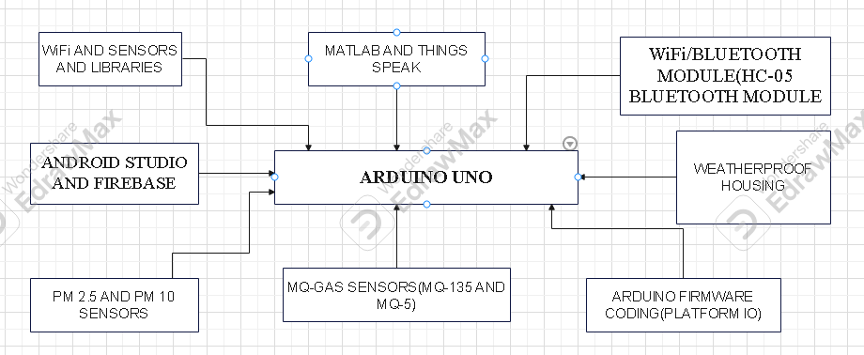
Figure 3.2.1:ARCHITECTURAL DIAGRAM OF ARDUINO UNO

ESP32
The architectural diagram of our final year project of ESP32 figure as shown below:
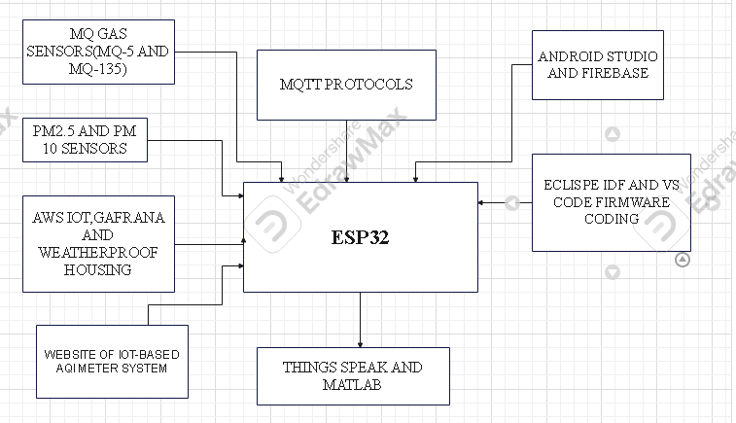
Figure 3.2.2:ARCHITECTURAL DIAGRAM OF ESP32

ESP8266
The architectural diagram of our final year project of ESP8266 figure as shown below:
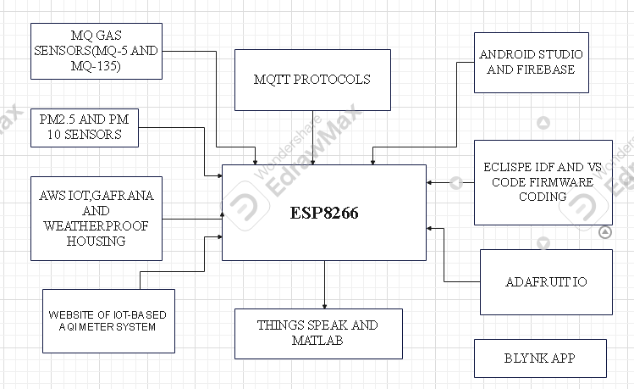
Figure 3.2.3:ARCHITECTURAL DIAGRAM OF ESP8266

MQ-GAS SENSORS(MQ-5 AND MQ-135)
The architectural diagram of our final year project of MQ-GAS SENSORS(MQ-5 AND
MQ-135) figure as shown below:
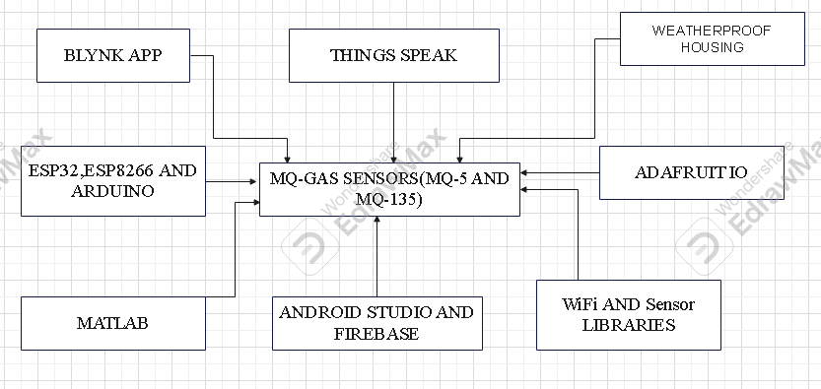
Figure 3.2.4:ARCHITECTURAL DIAGRAM OF MQ-GAS SENSORS(MQ-5 AND MQ-135)

PM2.5 AND PM10 SENSORS
The architectural diagram of our final year project of PM2.5 and PM10 SENSORS figure as shown below:
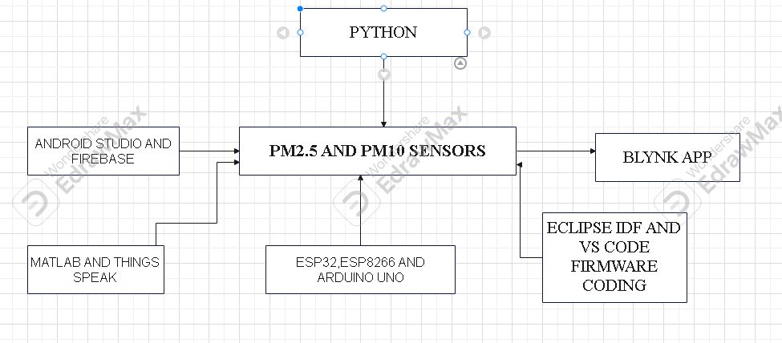
Figure 3.2.5:ARCHITECTURAL DIAGRAM OF PM2.5 AND PM10 SENSORS

WEATHERPROOF HOUSING
The architectural diagram of our final year project of weatherproof housing figure as shown below:
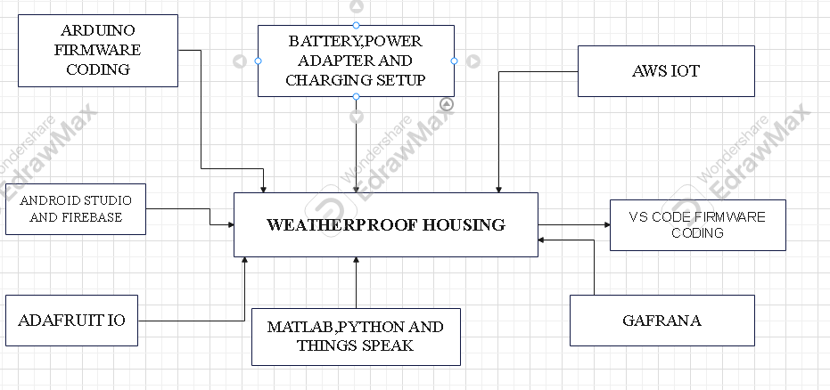
Figure 3.2.6:ARCHITECTURAL DIAGRAM OF WEATHERPROOF HOUSING

ANDROID STUDIO AND FIREBASE
The architectural diagram of our final year project of android studio and firebase figure as shown below:
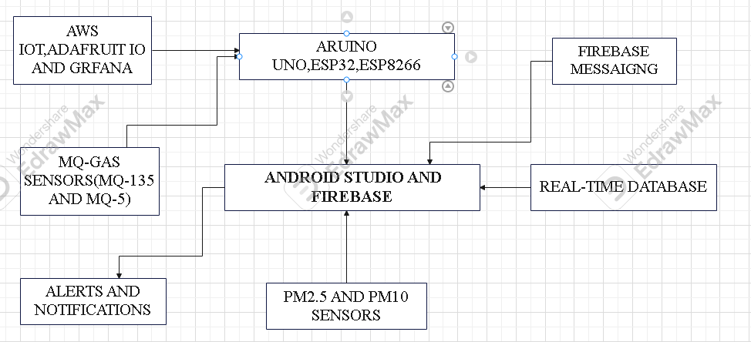
Figure 3.2.7:ARCHITECTURAL DIAGRAM OF ANDROID STUDIO AND FIREBASE

BLYNK APP
The architectural diagram of our final year project of blynk app figure as shown below:
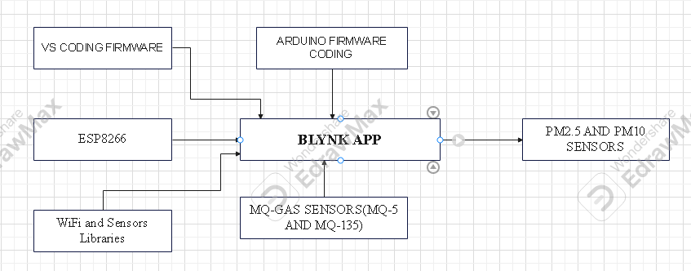
Figure 3.2.8:ARCHITECTURAL DIAGRAM OF BLYNK APP

MATLAB
The architectural diagram of our final year project of matlab figure as shown below:
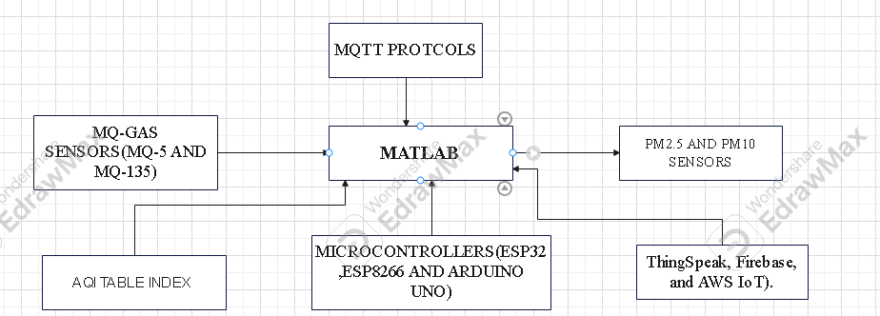
Figure 3.2.9:ARCHITECTURAL DIAGRM OF MATLAB

PYTHON
The architectural diagram of our final year project of python figure as shown below:
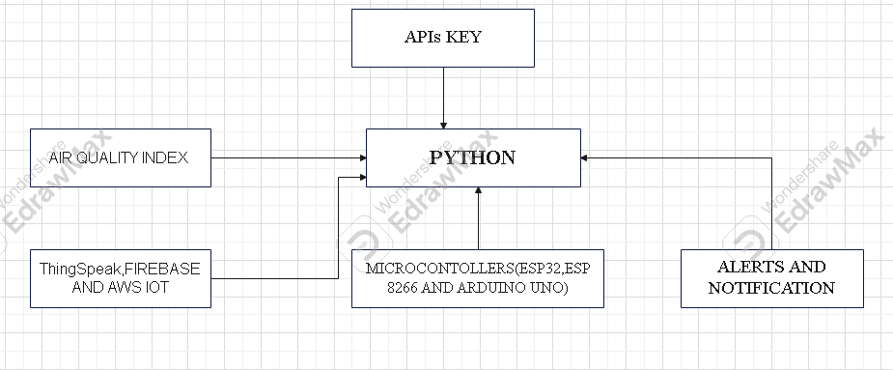
Figure 3.2.10:ARCHITECTURAL DIAGRAM OF PYTHON

SYSTEM ARCHITECTURE OVERVIEW
The design of an IoT-based Air Quality Index (AQI) Monitoring System is a worthy and commendable venture that tackles pressing environmental issues. Such systems generally have multiple components that are essential in ensuring accurate and real-time air quality monitoring.

SENSING LAYER
This layer is involved in both the detection and measurement of various pollutants in the air. Default items include:
- SENSORS:
In order to detect MQ-135(SO₂,NO₂,O₃ and CO) and MQ-5 (SnO₂,H₂, LPG, CH₄, CO and Alcohol) and particulate matter of sizes PM2.5 and PM10, devices have been developed. The sensors are capable of converting various physical phenomena into electrical signals for further processing.
- MICROCONTROLLER UNIT(MCU):
The core processing unit compiles data from the sensors, processes it in an initial stage, and handles various protocols for data communication. For example, the ESP32 and ESP8266 microcontroller have been successfully implemented in such systems for the dedicated Wi-Fi integrated and efficient processing capabilities. The Arduino UNO microcontroller has been successfully implemented in such systems for the dedicated Wi-Fi,Bluetooth integrated and efficient processing capabilities.

COMMUNICATION LAYER
The primary benefit of this layer is that it ensures the convergence of data from sensors and their transmission to centralized servers or cloud environments.
- Communication Modules:
Wireless transmission of data is possible by the utilization of Wi-Fi and HC-05 (Bluetooth module). The module that best fits a solution depends on aspects like range, power requirements, and data requirements.
- Protocols:
Implementing the use of standardized communication protocols, such as MQTT and HTTP/HTTPS, could constitute a highly reliable and efficient mode of data exchange between devices and the servers.

DATA PROCESSING AND STORAGE LAYER
Once the data is received, this layer takes charge of the processing, analysis, and storage of the data. Key components include:
- CLOUD COMPUTING PLATFORMS:
There are scalable resources available from AWS, Azure, Google Cloud for real-time processing and storage.
- DATABASE:
Data stores, also known as structured storage solutions, such as SQL databases, GAFRANA databases, AdafruitIO database and real-time database are an organizational measure to ensure efficient retrieval and analysis.
- Data Analytics Tools:
These various machine learning algorithms and statistical tools are pivotal in the interpretation of data patterns, forecasting the pollution trend, and generating implementable solutions.

APPLICATION LAYER
This interaction layer provided interfaces for stakeholders to engage with the system. Said interfaces included:
- Web and Mobile Applications:
A user-friendly facility will provide the real-time air quality data together with historical perspectives and predictive analytics. Such applications can also send alerts whenever the pollutants in the air reach defined thresholds.
- APIs:
Application Programming Interfaces allow third party developers access to data so that they can integrate it into other applications or services, thereby enabling and extending value and innovation.

POWER MANAGEMENT LAYER
This layer mainly focuses on ensuring continuous operation, specifically in remote areas:
- Power Sources:
Incorporation of renewable energy sources, such as solar panels and weatherproof housing can provide sustainable power solutions for the sensing units.
- Energy Harvesting Modules:
These modules collect and store energy from environmental sources, enhancing the system's autonomy and reducing maintenance requirements.

SYSTEM ARCHITECTURE DIAGRAM
The system architecture diagram of air quality index meter system figure as shown below:
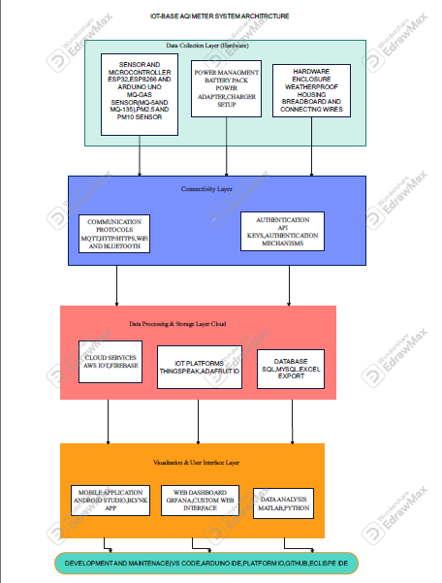
Figure 3.2.11:SYSTEM ARCHITECTURE OF AIR QUALITY INDEX METER SYSTEM

SENSOR SELECTION AND INTEGRATION

SELECTION OF SENSORS
Choosing the right sensors is very important for the appropriate collection of environmental data from an IOT-based AQI Meter System. These are categorized as gas and particulate matter sensors. All had their sensitivities, response times, power consumption, and environmental stability checked.
- Particulate matter(PM0 sensors:
Particulate matter sensors are built to detect the earth's atmosphere and its array of particles or the load that might form a hazardous environment or affect human respiratory health.
- PM2.5 and PM10 Sensors (PMS5003 or SDS011):
Using laser diffuser technology to measure fine particulate matter concentrations, these sensors have high sensitivity to airborne pollutants.
- Selection Justification:
The choice of the PMS5003 unit is made on the back of its high accuracy and compact design, and not to forget, low power consumption which makes it unarguably fit for IOT-based deployments.
- GAS SENSORS:
The detection of toxic gases is vital for the calculation of AQI. The system consists of MQ series gas sensors which are based on semiconductor technology and operate on the principle of measuring change in resistance when gas is absorbed.
- MQ-135:
Detects SO₂,NO₂,O₃, benzene, CO and smoke making it suitable for air pollution monitoring.
- MQ-5:
Specializes in detecting SnO₂,H₂, LPG, CH₄, CO and Alcohol essential for detecting potential leakages in urban environments.
- Selection Justification:
These sensors are frequently utilized since they are cheap and have a long detection range. But because the environmental parameters have a large influence on the accuracy of their readings, they need regular calibration.

SENSOR INTEGRATION WITH IOT PLATFORMS
- HARDWARE INTEGRATION:
The sensors and an ESP32,ESP8266 and Arduino UNO microcontroller are interconnected so that an ESP32,ESP8266 and Arduino UNO microcontroller processes the data and subsequently relays it to the cloud for constant supervision.
- MICROCONTROLLER UNIT(MCU):
The ESP32 and ESP8266 is selected for its built-in Wi-Fi and the Arduino Uno is selected for its built-in Bluetooth capabilities, enabling seamless data transmission.
- COMMUNICATION PROTOCOLS
- UART (Universal Asynchronous Receiver-Transmitter) Protocol:
Used for PMS5003 sensor data transfer.
- Analog-to-Digital Conversion (ADC):
MQ gas sensors require a voltage between 3 and 5 volts and the sensor provides an analog meter in return.
- SOFTWARE AND CLOUD INTEGRATION:
Sensor data is collected, processed, and sent to cloud platforms for real-time visualization and analysis.
- FIRMWARE DEVELOPMENT:
Implemented in ESP-IDF(C/C++),ARDUINO IDE AND PLATFORM IO.
- DATA TRANSMISSION:
- MQTT Protocol:
The data was sent by network to specific platform such as ThingSpeak, Firebase, AWS IoT and ADAFRUIT IO.
- HTTP/HTTPS API Calls:
Very useful for app integration for mobile using Blynk, Android studio and online visualization with Grafana.
- DATA PROCESSING WITH CALIBRATION
- Baseline Calibration:
Calibrating sensors makes them work better in terms of accuracy and the true air quality values, as measured by authorities, can be acknowledged for cross-validation.
- Noise Reduction:
Listening to the information through malformed audio mike, the programming skill equates current activities with intelligence.
- AI Integration:
Future implementations may employ machine learning models to predict air quality trends based on historical data.

CHALLENGES AND FUTURE DEVELOPMENT
- Sensor Drift:
MQ-series sensors require periodic calibration as their sensitivity degrades over time.
- Data Fusion and Error Correction:
Kalman filtering and Machine-learning models such as Python and MATLAB were adopted to fine-tune the filtering of datasets.
- Energy Efficiency:
The power optimization strategies, which embrace sleep mode design, are ready to increase battery life for team's ESP32.
- Cloud-Based AI Integration:
Implementation of future analytics with AI capabilities for predictive forecasting of air quality.

DATA ACQUISTION AND DATA PROCESSING
Due to the escalating effects of air pollution on human health and environment, real-time monitoring of air quality is nowadays imperative. The IOT-based air quality index (AQI) meter system incorporates sensor networks, microcontrollers, and cloud computing for the measurement and analysis of air pollutants. The real-time monitoring system simultaneously collects data on PM2.5, PM10, MQ-135(SO₂,NO₂,O₃ and CO) and MQ-5 (SnO₂,H₂, LPG, CH₄, CO and Alcohol). for a data-centered approach to environmental monitoring. With the integration of IOT and cloud platform, users can access both real-time and historical data to make decisions and for early warning systems.

DATA ACQUISTION
The system utilizes a range of sensors connected to ESP32, ESP8266 and Arduino Uno to acquire environmental data. The key components include:
- Particulate Matter Sensors (PM2.5 & PM10):
Concentration of fine particulate in µg/m³ an important air pollutant.
- MQ-GAS SENSORS(MQ-135 AND MQ-5):
Use to detect harmful gases such as SO₂,NO₂,O₃, CO, SnO₂,H₂, LPG, CH₄, CO and Alcohol vapors.
- Wi-Fi modules(ESP32 and ESP8266):
Provides wireless connectivity and real-time data transmission to the cloud.

DATA PROCESSING
The data captured from the sensors goes through various phases of processing.
- SIGNAL CONDITIONING:
- Data from sensors are translated into analog electric signals, and these transferred electric signals pertaining to manifold connected sources are collectively subjected to electronic processing to remove unwanted disturbances giving rise to the noise.
- Digital sensors offer direct readings but necessitate calibration based on environmental conditions.
- DATA CONVERSION AND CALIBRATION
- Analog-to-Digital Conversion (ADC):
The system converts raw sensor data into digital format that it can then process.
- Sensor Calibration:
Improves the precision by the assist or use of either manufacturer-defined lookup tables or machine-learning models.
- DATA TRANSMISSION
Once processed, the data is transferred to cloud platforms like ThingSpeak, Firebase, AWS IoT and Adafruit IO through HTTP/HTTPS and MQTT. These protocols secure and enable efficient communication between the IoT device and the server.
- DATA STORAGE AND VISUALIZATION
- Cloud platforms provide a convenient storage solution for analyzing both real-time and historical air quality data.
- Visualization tools such as Grafana, Blynk, MATLAB, PYTHON and Excel generate real-time charts and trends.
- The AQI is computed on the basis of standards used by the WHO and EPA, so alerts are issued if the pollution levels breach set limits.

AI-BASED PREDICTIVE ANALYSIS(FUTURE ENHANCEMENT)
Incorporation of AI and machine learning algorithms in a system can result in higher accuracy and efficiency.
- Predictive Air Quality Analysis:
Forecast future pollution levels based on historical data.
- Anomaly Detection:
Monitor the pollution levels for unusual spikes, triggering alerts.
- Adaptive Sensor Calibration:
Adjust sensor readings dynamically based on environmental conditions.

CLOUD CONNECTIVITY AND DATA STORAGE
The integration of cloud computing provides real-time monitoring, storage, and analysis for environmental parameters such as PM2.5, PM10, MQ-5 and MQ-135 levels within the framework of an IoT-based Air Quality Index (AQI) Meter System. The air quality system comprises ESP32, ESP8266, and Arduino Uno, which support data acquisition with sensor data transmission to various cloud platforms including ThingSpeak, Firebase, AWS IoT, and Adafruit IO. This chapter discusses the cloud connectivity architecture, communication protocols for data transmission, data storage techniques, and security issues of the system.

CLOUD CONNECTIVITY ARCHITECTURE
The AQI meter system is built with a three layer cloud architecture:
- PERCEPTION LAYER:
Contains Arduino Uno, ESP32, ESP8266, sensors (MQ-135, MQ-5, PM2.5and PM10) to sniff environmental pollutants.
- NETWORK LAYER:
Further, connect it to cloud wireless networking through Wi-Fi (IEEE 802.11) and communication language: MQTT, HTTP and the like.
- APPLICATION LAYER:
This lies as the cloud dashboard (Firebase, ThingSpeak, AWS IoT, Adafruit IO, Grafana, etc.), from which a common stream of AQI data is shared.

ROLE OF ARDUINO UNO IN CLOUD CONNECTIVITY
Arduino Uno does not come with any internal Wi-Fi but forms an important part of acquiring sensor data and preprocessing it into some form before transferring it over either an ESP32 or an ESP8266 device. Here is how one gets to connect the device to the cloud:
- Using an ESP8266 WiFi module with Arduino uno:
The ESP8266 is a Wi-Fi bridge that transmits data from Arduino to the cloud.
- Using an Ethernet Shield:
The W5100-based Arduino Ethernet Shield can make a system availed to the internet for cloud communication.
- Using a GSM Module:
Permits the image to always be up-to-date with the significant changes required to get signals even when Wi-Fi is unable to reach certain premises.

DATA TRANSMISSION PROTOCOLS
As the system is responsible for reliable data transfer so it implements set of protocols to make successful connection possible as being mentioned below:
- MQTT (Message Queuing Telemetry Transport):
A light publish-subscribe protocol which has been most suitable for applications in IoT because of how its energy consumption has been very low and utilizes very minimal bandwidth.
- HTTP/HTTPS (Hypertext Transfer Protocol):
Utilized as an intermediary for REST API communication between the IoT device and cloud platforms like ThingSpeak and Firebase.
- WebSockets:
Enabling real-time bidirectional communication between the AQI meter as well as the cloud dashboard can be beneficial, enhancing response time.

DATA STORAGE MECHANISMS
The AQI system based on the IoT provides support on real-time and historical data storage solutions to support analysis and decision-making based on the generated data.

CLOUD-BASED STORAGE PLATFORMS
- Firebase Realtime Database:
AQI readings are saved in a structured JSON format, rendering synchronization in real time an exclusive feature across all the multiple devices.
- AWS IoT Core and DynamoDB:
The platform offers scalable cloud storage for structured data, enabling predictive analytics and AI-driven insights.
- ThingSpeak:
An IOT cloud data analytics platform making sense of time series of data to unveil environmental issues beyond visualizing quality trends of air.
- Adafruit IO:
Data visualizing IOT and connecting IoT data to third-party applications is what cloud services do.

DATA PROCESSING AND ANALYSIS
Stored AQI data is analyzed using:
- MATLAB and Python:
For statistical interpretations, trend forecasting, and anomaly detection.
- Grafana and Excel:
For showing in visual manner the Air Quality trending over time.
- Edge Computing (ESP32 & ESP8266):
The elimination of preprocessing would significantly reduce the load on the sensor to send data to the cloud but would increase latency and bandwidth usage.

INTEGRATION OF ARDUINO UNO WITH CLOUD STORAGE
- Using Arduino IOT Cloud:
An enabling support that incorporates itself directly with Arduino MKR Wi-Fi 1010, Arduino Nano 33 IOT, and its compatible boards.
- Using Google Firebase with Arduino:
The partnership of an ESP8266 or ESP32 module with the cloud makes it possible to send data from Arduino Uno via Wi-Fi with Firebase.
- Using AWS IoT with Arduino:
MQTT via ESP8266 is the protocol that moves sensor data from Arduino towards AWS IOT Core.

SECURITY AND PRIVACY CONSIDERATIONS
For cloud-based IoT systems, the completion of integrity, confidentiality, and availability of data is a significant issue. Something such as the AQI system is ingrained with:
- Authentication & Encryption:
API authentication, secure socket layer protocols, and OAuth must be verified and enforced on the system standard capabilities for secure data transmission between IoT device and service/the cloud.
- Access Control:
The system is implementing role-based access control (RBAC) to prevent unauthorized access to data.
- Data Redundancy & Backup:
Cloud storage providers like AWS S3 and Firebase Cloud Storage ensure high availability via data replication.

DATA VISUALIZATION AND USER INTERFACE
This study presents a case of the data visualization and user interface (UI) of an IOT-aided Air Quality Index (AQI) Meter System focusing on real-time environmental monitoring through sensor integration, cloud storage, and user-friendly interfaces. With respect to data representation, tools such as Grafana, Firebase, ThingSpeak, and Adafruit IO are incorporated in the system, while sensor data collection and transmission are facilitated via the components used; the ESP32, ESP8266, and Arduino Uno. The study also discusses UI design principles that optimize user engagement and usability. The IOT-based AQI monitoring systems collect environmental data from multiple sensors, including PM2.5, PM10, and MQ-series gas sensors(MQ-5 AND MQ-1350, and transmit it to cloud platforms for visualization via ESP32, ESP8266 and Arduino Uno. The Arduino Uno is the primary data acquisition device, and the ESP32 and ESP8266 are important for wireless communication, providing the capability for remote access and visualization.

DATA VISUALIZATION IN IOT-BASED AQI SYSTEMS
Data visualization turns raw sensor readings into useful insights through graphical representations such as line graphs, bar charts, heat maps, and gauge meters. Important factors in the selection of visualization tools include data frequency, real-time processing abilities, and user requirements.

ROLE OF ARDUINO UNO IN DATA ACQUISITION
- Sensor Interfacing:
The Arduino Uno samples data from sensors MQ-135, MQ-5, PM2.5, and PM10 through the different I/O pins, digital and analog.
- Pre-Processing:
Utility of these sensors is then derived by its conversion into meaningful data.
- Data Transmission:
Sensor data is uploaded to the ESP32/ESO8266 for wireless broadcasts.

VISUALIZATION TOOLS AND PLATFORMS
An effective visualization of the air quality data based on IoT is provided by various platforms:
- Grafana:
Allows for updating with input across each website and one may directly contact their concerned page developer with the same.
- ThingSpeak:
Offers cloud-based analytics and visualization for IoT applications.
- Adafruit IO:
With interactive charts, one can simplify IoT data visualization.
- Firebase Realtime Database:
Enables mobile app-based real-time data updates.
- MATLAB and Python:
It is used for processing complex data and modeling predictions.

DATA REPRESENTATION TECHNIQUES
- Time-Series Graphs:
It shows the development of pollution quantities in a graphic form as a function of time.
- Gauge Meters:
Indicate real-time AQI values.
- Heatmaps:
Visual depiction of pollution intensity among multiple locations.
- Push Notifications & Alerts:
Let users know when air meets critical thresholds.

USER INTERFACE DESIGN
Functionality and usability are enhanced when a UI is well-designed. The UI is built using Android Studio (Java/XML) for mobile applications and web dashboards built using React.js, HTML, CSS, and JavaScript.

UI DESGIN PRINCIPLES
The AQI meter system observes typical UI/UX principles as laid down.
- Simplicity:
Minimalistic design with easy navigation.
- Clarity:
Data presentation at its best shows AQI levels color-coded for each kind of pollution (i.e. green for air that is good, red for air that is bad).
- Responsiveness:
Design for multiple devices (smartphones, tablets, desktops).
- User Customization:
Setting parameters for the user to change alert-setting styles to include email, frequency, and data filter preferences.

FEATURES OF THE MOBILE AND WEB UI
- Live AQI Dashboard:
The system displays real-time AQI levels.
- Historical Data Analysis:
The feature enables users to view historical trends.
- Location-Based Data:
The GPS is put into service to collect pollution details in different zones.
- Push Notifications:
The user will receive a pop alert as soon as AQI reaches the level of mental peace-blowing troubling.

DATA FLOW BETWEEN ARDUINO UNO,ESP32 AND UI
- The Arduino Uno board collects sensor data and pre-processes them.
- The data processed gets sent serially to an ESP32 or an ESP8266.
- ESP32/ESP8266 uploads its data stream to cloud platform (Firebase, ThingSpeak, Adafruit IO).
- To visualize the real-time data, one must download a mobile app and web dashboard that access data from the cloud.

CHAPTER FOUR

SYSTEM DESIGN AND IMPLEMENTATION

OVERVIEW
The present invention relates to the development of an Internet of Things (IoT)-based Air Quality Index (AQI) Meter System for online monitoring and measurement of environmental parameters such as PM2.5, PM10, temperature, humidity, and concentrations of harmful gases such as CO, NO₂, and O₃ in the air. The system consists of microcontrollers, sensors, wireless communication modules, and cloud-based platforms-including ThingSpeak, Firebase, and AWS IoT-for real-time monitoring data visualization and analysis. The implementation revolves around ESP32, ESP8266, and Arduino Uno with an efficient data acquisition and transmission strategy. In addition, firmware is built using VS Code, PlatformIO, and Arduino Framework while version control is enabled using GitHub. Literally speaking, it is an IoT-enabled Air Quality Meter system which is capable of monitoring the environmental parameters PM2.5, PM10, temperature and humidity, as well as CO, NO2, and O3 pollution. Systems are including microcontrollers, sensors, wireless communication modules, and cloud-based platforms such as ThingSpeak, Firebase, and AWS IoT for real-time method monitoring, visualization, and analysis. The implementation focuses on the ESP32, ESP8266, and Arduino Uno in efficient data collection and transmission. The firmware is developed using VS Code, PlatformIO, and the Arduino Framework, while version control is done using GitHub.

SYSTEM DESIGN
An IOT-driven AQI Meter System follows a modular architecture, underneath which lies a host of hardware as well as software modules.

HARDWARE COMPONENTS
- MICROCONTROLLERS
- ESP32 and ESP8266:
It manages data gathering, processing, and wireless transmission.
- ARDUINO UNO:
It acts as an integration interface to some additional sensors and also offers this so-called peripheral control.
- SENSORS
- PM2.5 AND PM10 SESNORS:
Measures fine particulate matter concentrations.
- MQ-Series Gas Sensors (MQ-135, MQ-5):
Detect gases like SO₂,NO₂,O₃,CO, SnO₂,H₂, LPG, CH₄, CO and Alcohol vapors.
- WIRELESS MODULES
- Wi-Fi Modules (ESP8266 and ESP32):
Enables data transmission to cloud servers.
- Bluetooth Modules (HC-05):
Interacts with native libraries to deal with mobile application locals.
- POWER SUPPLY AND HOUSING:
Rechargeable battery with power management.
Weatherproof housing for outdoor deployment.

SOFTWARE COMPONENTS
- FIRMWARE DEVELOPMENT:
Arduino Framework and ESP-IDF for microcontroller programming.
VS Code, PlatformIO IDE and Arduino IDE for firmware development.
Libraries for intermediate software development for data acquisition in a sensor network bingo.
GitHub is used for both version control and collaborative development.
- Cloud and Networking:
ThingSpeak along with Firebase and AWS IOT are used for storing and visualization of real-time data.
Transport Layer Security (TLS) support is what MQTT and HTTP/HTTPS are recommended to use for transmitting securely.
- Data Processing and Mobile Application Development:
Python and MATLAB for real-time data analysis.
Android Studio (Java, XML) for mobile app development.
Grafana and Adafruit IO for web-based visualization.

IMPLEMENTED OVERVIEW
Sensors would be connected to either the ESP32/ESP8266 or the Arduino Uno depending on its power and communication needs. Environmental parameters are continuously measured by these sensors, and data is conditioned through ADC to be formatted for cloud transmission.

WIRELESS COMMUNICATION AND CLOUD INTEGRATION
The system supports dual communication modes:
- Wi-Fi Communication:
The ESP32 or ESP8266 push actual-time details to Firebase, AWS IoT, or ThingSpeak over MQTT and HTTP/HTTPS protocols.
- Bluetooth Communication:
An SDK building local connectivity will monitor the site through a mobile app.

DATA PROCESSING AND VISUALIZATION
- Data from the sensors are processed locally on ESP32 / ESP8266 and Arduino Uno.
- Cloud services are used for data management and services such as data persistence and retrieve.
- Grafana, MATLAB and Adafruit IO dashboards show real-time data views.

POWER MANAGEMENT AND OPTIMIZATION
- The platform wants to create a programmatic framework that establishes new morals, challenges new ideals, and leaves the world behind.
- The power management circuit on a rechargeable battery ensures an operation without any pauses.

HARDWARE COMPONENTS USED
This IoT-based air quality index (AQI) meter system comprises several hardware components for accurate environmental monitoring, real-time data processing, and efficient wireless communication. Some of these components include:
- ESP32 AND ESP8266:
Microcontrollers that do processing and communication are offering Wi-Fi and Bluetooth in one application.
- ARDUINO UNO:
A microcontroller board is utilized for sensor integration and data acquisition.
- MQ SERIES GAS SENSOR(MQ-135 AND MQ-5):
Detects air pollutants such as SO₂,NO₂,O₃,CO, benzene, and smoke. Monitors gases such as SnO₂,H₂, LPG, CH₄, CO and Alcohol vapors.
- PM2.5 AND PM10 SENSORS:
Measure fine particulate matter (PM) concentrations in the air.
- BATTERY PACK,POWER ADAPTER and CHARGER SETUP:
Make a system available for power distribution and backup so as to provide an uninterrupted run.
- WEATHERPROOF HOUSING:
Such interventions against environmental conditions are aimed at safeguarding sensors and electronics.
- WiFi/BLUETOOTH MODULES:
The primary purpose of the tractor is to protect the sensors and electronics from the environmental conditions, including vibrations and humidity.
- BREADBOARD AND CONNECTING WIRES:
Serve in prototyping a circuit and establishing connections between the components.

FIRMWARE DEVELOPMENT FOR ESP32,ARDUINO UNO AND ESP8266
Firmware provides itself for IOT based air quality index (AQI) meter system development through Arduino Framework, under Visual Studio Code (VS Code), PlatformIO IDE and Eclipse IDF for ESP32 and ESP8266. Analog sensor readings are processed before transmission to ESP-based modules using the Arduino Uno. The program firmware implements many basic functions, such as sensor data acquisition, wireless communication, and data processing with an Over-the-Air (OTA) update feature, eventually for near real-time monitoring and remote access to air quality.

SENSOR DATA ACQUISITION
Acquisition of sensor data using SPI communication depends upon the type of sensor. The firmware initializes the sensor and retrieves real-time environmental parameters such as PM2.5, PM10, MQ-135(SO₂,NO₂,O₃ and CO) and MQ-5 (SnO₂,H₂, LPG, CH₄, CO and Alcohol). Some important steps in the process include:
- Sensor Initialization:
Setting up communication protocols under SPI where you define the parameter peculiar to a sensor.
- Data Polling:
In order to ensure periodic fault detection, we would consider checking sensor readings from time to time.
- Data Storage:
Hold on to the acquired readings for supplemental processing and transmission.

WiFi AND MQTT COMMUNICATIONS
The firmware configures any of the ESP32/ESP8266 to connect with a stable Wi-Fi and then send the commands to the cloud platforms through MQTT or HTTP POST. The communication process consists of:
- Wi-Fi Configuration:
Access to a secure Wi- Network with the SSID and Password saved in Non-Volatile Storage (NVS) for a constant status for the credentials is needed.
- MQTT Implementation:
Real-time sensor data to be published on the MQTT broker. The broker will carry the data forward to cloud-based IoT such as Firebase, AWS IoT, ThingSpeak and Adafruit IO.
- HTTP POST Integration:
Specific studies include telemetry deployed in various weather stations and urban weather stations, where analog data are shared with computer networks and form part of a wide network of geolocated systems. Sensor data transmission to web servers or cloud databases for further processing and visualization.

DATA PROCESSING AND STORAGE
In addition to accuracy and dependability, what also constitutes the objectives of the firmware is the implementation of real-time data process techniques for air quality data.
- Noise Reduction:
One way of accomplishing this is by using a moving average and median filtering technique on sensor readings.
- Data Calibration:
The measures can be calibrated with the help of reference values to improve the accuracy of the revisit with the various compensation parameters pointed to the weather conditions.
- Non-Volatile Storage (NVS):
It ensures important data such as network access and Wi-Fi passwords across system reboots.

OVER-THE-AIR(OTA) FIRMWARE UPDATES
Firmware Supports Over-the-Air (OTA) Updates that ensure the scalability and remote management, thereby allowing developers to update device firmware without needing to physically access the update application. The OTA mechanism provided includes the following elements:
- Firmware Upload via Web Server or Cloud Service:
Enabling secure updates from a remote server.
- Verification and Integrity Check:
Ensuring the ability for the successful firmware downloads with checksum validation.
- Automatic Restart and Rollback Mechanism:
Restart microcontroller with new programmed firmware, retaining the most important settings.

ARDUINO UNO INTEGRATION
Besides ESP32 and ESP8266, we use an Arduino Uno for data acquisition and preprocessing certain analog sensors before transmitting readings to the ESP modules. The firmware is uploaded onto the Arduino Uno:
- The device reads analog sensor values and converts them into digital format.
- Just communicate to the SPI by using higher TX/RX pins, especially inside the ESP8266; two inverters are put together for eliminating any need to have a real inversion.
- The process involves initial filtering to minimize noise before transmitting data to cloud services.

WIRELESS COMMUNICATION AND PROTOCOLS USED
The IoT-based Air Quality Index (AQI) Meter System is an environmental monitoring system using a set of microcontroller utopias like ESP32, ESP8266, and Arduino Uno to track PM2.5, PM10, MQ-135(SO₂,NO₂,O₃ and CO) and MQ-5 (SnO₂,H₂, LPG, CH₄, CO and Alcohol) . The environment uses wireless communication technologies for real-time data transmission across the sensors, edge devices, cloud platform, and user interface. The system uses several wireless communication protocols for reliable, low-power, and efficient data exchange.

WIRELESS COMMUNICATION TECHNOLOGIES FOR IOT-BASED AQI METER SYSTEMS
Different microcontrollers in the system use a variety of wireless communication methods based on range, power consumption, and data rates.
- WiFi(IEEE 802.11)-USED WITH ESP32 AND ESP8266:
ESP32 and ESP8266 communicate over Wi-Fi in order to send the air quality data to cloud services. This is mostly used for transmitting data to Firebase, ThingSpeak and AWS IOT.
- Advantages:
The product boasts a high data rate and is compatible with cloud services.
- Limitations:
The device has a higher power consumption and a limited range of approximately 100 meters indoors.
- Bluetooth Low Energy (BLE) – Used with ESP32:
In local monitoring, BLE is being used to allow ESP32 and mobile apps to communicate over short-range communication.
- Advantages:
This device is highly efficient and has low power consumption, making it perfect for mobile device integration.
- Limitations:
The communication range is limited to approximately 10-30 meters.
- LoRaWAN (Long Range Wide Area Network) – Optional for Long-Range AQI Monitoring:
LoRaWAN is a technology that aids in remote AQI monitoring by transmitting small data packets over long distances.
- Advantages:
The device boasts a long range of up to 15 km and is known for its low power consumption.
- Limitations:
The low data rate necessitates the use of a LoRa gateway.
- Zigbee (IEEE 802.15.4) – Used for Mesh Networking:
In a multi-sensor AQI system where there are lower-power mesh network communications, Zigbee is utilized.
- Advantages:
The device is designed to be low power consumption and scalable for multi-sensor setups.
- Limitations:
The device has a limited data rate and a short range of approximately 100 meters.
- Cellular Networks (4G/5G, NB-IoT) – Used for Remote AQI Monitoring:
Remote areas are benefiting from AQI monitoring's worldwide coverage through cellular networks.
- Advantages:
The data transmission is reliable and wide-ranging.
- Limitations:
The potential data costs may increase due to higher power consumption.
- Serial Communication (UART, I2C, SPI) – Used with Arduino Uno:
Despite not being equipped with built-in wireless capabilities such as Wi-Fi or BLE, Arduino Uno can communicate with sensors or modules using different protocols such as UART, I2C, or SPI to interface with ESP32/ESP8266.
- Advantages:
Solid wire connection between a pair of microcontrollers.
- Limitations:
The device necessitates an additional wireless module, either the ESP8266 or LoRa shield.

PROTOCOLS USED IN IOT-BASED AQI METER SYSTEM
The AQI Meter System uses various standard Internet of Things communication protocols to ensure fast, secure, and efficient data exchange or data monitoring.
- Message Queuing Telemetry Transport (MQTT) – Used with ESP32/ESP8266:
MQTT is more of a lightweight publish-subscribe protocol focused on transmitting AQI data to cloud platforms like AWS IoT, Adafruit IO, and ThingSpeak.
- Advantages:
Supports Quality of Service (QoS), while using little bandwidth.
- Limitations:
The statement requires an MQTT broker.
- Hypertext Transfer Protocol (HTTP/HTTPS) – Used with ESP32/ESP8266:
Speaking of communication, API-based data arrival on cloud dashboards happens through the medium of web-based HTTP/HTTPS communication.
- Advantages:
The website is secure and widely supported through HTTPS.
- Limitations:
The power consumption and overhead are higher compared to MQTT.
- Constrained Application Protocol (CoAP) – Alternative to HTTP:
CoAP is a lightweight protocol optimized for constrained IoT devices that deals with fast and low-power AQI data transmission.
- Advantages:
Low energy use. UDP is based for rapid communication.
- Limitations:
The support provided is limited compared to HTTP/MQTT.
- Advanced Message Queuing Protocol (AMQP) – For Secure IoT Communication:
The principle of AMQP is to ensure secure exchange of message oriented data through a scalable interaction between the IoT devices and cloud applications.
- Advantages:
The system is secure and capable of handling high-volume data exchange.
- Limitations:
The complexity of the statement is higher than that of MQTT.
- Serial Communication Protocols (UART, I2C, SPI) – Used for Arduino Uno Integration:
Due to its absence of built-in wireless communication, Arduino Uno sends sensor data to ESP32 or ESP8266 using serial protocols.
- UART (Universal Asynchronous Receiver-Transmitter):
ESP8266 permits an Arduino to use ESP8266 to exchange data.
- IIC (Inter-Integrated Circuit):
This device is utilized for multi-sensor communication.
- SPI (Serial Peripheral Interface):
This device is utilized for the transfer of high-speed sensor data.

CLOUD SERVICES AND DATABASE INTEGRATION
In the IoT Air Quality Index (AQI) Meter System, cloud services and databases are essential for data acquisition, storage, processing, and real-time monitoring. The system with the help of ESP32, ESP8266, and Arduino Uno collects environmental data including PM2.5, PM10, SO₂,NO₂,O₃ ,CO, SnO₂,H₂, LPG, CH₄, CO and Alcohol utilizing sensors such as MQ-135, MQ-5, PM2.5 and PM10. The processed data is sent to cloud platforms for real-time visualization and alerts based on specific threshold values. The data can then be used for long-term storage and analytics.

HARDWARE AND CLOUD CONNECTIVITY
- MICROCONTROLLER ROLES
- Arduino Uno:
The device serves as a primary data acquisition unit, interacting with sensors and transmitting data via ESP32 and ESP8266 using UART, I2C, or SPI protocols.
- ESP32 AND ESP8266:
The device serves as a communication gateway, handling Wi-Fi connectivity and transmitting sensor data to cloud platforms.
- Communication Protocols
The system employs Wi-Fi-based MQTT and HTTP/HTTPS protocols for secure and efficient data transmission to cloud databases.
- MQTT Protocol:
It serves for low latency, lightweight data transmission to platforms like AWS IoT, Adafruit IO, as well as Blynk.
- HTTP/HTTPS Protocol:
Primarily used for REST API communication with Firebase, ThingSpeak, and customers cloud servers.

CLOUD SERVICES INTEGRATION
Cloud platforms help to monitor the air quality data in real-time through the Internet. Some of the essential services used in this system are as follows:
- AWS IoT Core & DynamoDB:
- Device Management:
Secure communications between ESP32/ESP8266 and AWS cloud.
- Data Storage:
The scalable NoSQL database AWS DynamoDB stores sensor data.
- Analytics:
When pollution levels are above the threshold, AWS Lambda functions will take over and process the data to trigger notifications using the AWS Simple Notification Service (SNS).
- Firebase Realtime Database & Firestore:
- Mobile app integration needs a NoSQL-based fully synchronized database with JSON.
- Firebase Cloud Messaging (FCM) is utilized to send notifications when AQI levels exceed safe limits.
- ThingSpeak IOT Analytics:
- Signal processing and data visualization in real-time using the MATLAB based cloud system.
- Triggers causing pollution level warning alerts.
- Adafruit IO:
- The MQTT dashboard is utilized to provide real-time monitoring of sensor values.
- The process involves data logging and visualization for historical trend analysis.

DATABASE INTEGRATION
The AQI Meter System gets the benefits of structured and unstructured data storage using SQL and NoSQL databases.
- SQL DATABASE (MYSQL,POSTGRE SQL):
- It is structured data to store AQI readings with timestamps and location data.
- A single screen for remote monitoring, a cloud-based service, and great features for 4k are some of the features.
- NOSQL DATABASE(FIREBASE,AWS DYNAMODB):
- The system has been optimized for real-time updates and seamless integration with mobile apps.
- Sensor data is stored in an unstructured format so the cloud can process it.
- LOCAL STORAGE (SD CARD,EEPROM,NVS):
- The data produced from various sensors will be stored in the non-volatile EEPROM memory of the Arduino Board before transmitting to the cloud wirelessly via Wi-Fi/ BLE through ESP32/ ESP8266.
- Non-volatile storage of a microcontroller refers to memory chips in easily accessible locations, like flash memory, FRAM, or EEPROM, which are used to store data even after power is turned off.

REAL-TIME ALERTS AND DATA PROCESSING
- Alert messages based on thresholds using AWS SNS or Firebase Cloud Messaging (FCM).
- Real-time visualizations provided by Grafana and MQTT Dashboards.
- Using Artificial Intelligence and machine learning and making forecasts of the Air Quality Index (AQI) trends from a cloud platform.

SECURITY AND AUTHENTICATION
The system also makes use of the following for sensor data privacy and user identity preservation:
- Tokens from OAuth authentication and API keys are accessed upon the check for security prevention against unauthorized access.
- Secure cloud transmission via SSL/TLS encryption.
- Permission management is model-based data access control.

MOBILE APP DEVELOPMENT FOR AQI VISUALIZATION
Air pollution is becoming an issue on a global scale that needs real-time monitoring and visualization of air quality parameters. The idea behind this project is to create an application on mobile for visualizing AQI of an IoT based AQI Meter System. It fetches sensor data from the ESP32/ESP8266 based IoT nodes, performs processing, and displays through an interactive user interface. The system combines Firebase cloud storage for real-time updates and alert notifications when levels of pollutant.

SYSTEM ARCHITECTURE
Compared to traditional mobile applications, our application proposes a modular architecture. That means it is highly capable for scaling up faster and efficiently.
- HARDWARE COMPONENTS
- ARDUINO UNO,ESP32 and ESP8266:
Chip microcontroller for acquiring sensor data and sending it over a WiFi interface.
- SENSORS:
PM2.5, PM10, MQ-135 (SO₂,NO₂,O₃ and CO), MQ-5 (SnO₂,H₂, LPG, CH₄, CO and Alcohol).
- POWER SUPPLY:
A rechargeable battery pack comes along with a charger circuit in the complete form.
- SOFTWARE COMPONENTS
- ANDROID STUDIO:
Mobile development environments can be utilized to code for mobile software solutions.
- JAVA AND XML:
A front end and back end refer to the two different parts of a program interpreter.
- FIREBASE REALTIME DATABASE:
The data of AQIs need to be stored and synchronized via cloud storage in a step-wise manner.
- MQTT PROTOCOL:
The communication between IoT devices and the mobile app is crucial.
- THINGSPEAK AND BLYNK:
The best functions include the ability to perform real-time data analysis, visualize data as a multisource event, and create credible visuals.

- DATA PROCESSING WORKFLOW
- SENSOR DATA ACQUISTION:
Air quality is monitored reliably by the installation of IOT nodes that collect data.
- DATA TRANSMISSION:
The data is transmitted to Firebase via ESP32/ESP8266.
- MOBILE APP RETRIEVAL:
The app utilizes API calls to retrieve data.
- DATA VISUALIZATION:
Graphs, Color-coded AQI Indicators, and Notifications.
- ALERTS AND NOTIFICATIONS:
The system is designed to send push notifications for any violations of the AQI threshold.

MOBILE APPLICATION DEVELOPMENT
- FEATURES OF THE APPLICATION
- REAL-TIME AQI MONITORING:
The display provides real-time AQI values and pollutant levels.
- HISTORICAL DATA ANALYSIS:
A visual representation of historical data trends.
- THRESHOLD-BASED ALERTS:
Send notifications to warn people about hazardous air quality.
- USER AUTHENTICATION:
The system offers secure login and cloud-based user profiles.
- LOCATION-BASED AQI DATA:
The function retrieves data based on the user's location.
- IMPLEMENTATION IN ANDROID STUDIO
- FRONTEND(XML):
- The dashboard displays the AQI values.
- Interactive graphs of pollutant concentration trends.
- Condition monitors (Green: Good, Yellow: Moderate, Red: Hazardous).
- BACKEND(JAVA,FIREBASE):
- The Firebase Realtime Database is utilized for data storage.
- The use of an API integrator is an ideal method to retrieve and keep in order the API data of both the reporting stations and users.
- Real-time communication with IOT devices-working like of-the-moment MQTT.
- INTEGRATION OF CLOUD SERVICES:
- Firebase is a platform used for authentication and database management.
- ThingSpeak and Blynk for some cloud-driven data visualization.

BLYNK APP
Blynk is an IOT platform for real-time monitoring and control of an application connected through a mobile application. For this project, Blynk is employed to visualize the Air Quality Index (AQI) information provided by sensors and processed on ESP32/ESP8266. The app features an interactive dashboard for the current display of parameters of the environment, such as PM2.5, PM10, MQ-135 (SO₂,NO₂,O₃ and CO) and MQ-5 (SnO₂,H₂, LPG, CH₄, CO and Alcohol).

INTEGRATION OF BLYNK WITH ESP32/ESP8266
The following steps are followed to connect an ESP32/ESP8266 microcontroller with the Blynk cloud:
- BLYNK ACCOUNT CREATION:
- The user creates an account with Blynk and start-up the project.
- A unique Authentication Token is generated and sent via email.
- ADDING WIDGETS IN THE BLYNK DASHBOARD:
- GAUGE/VALUE DISPLAYS:
For real-time AQI readings.
- GRAPH WIDGET:
If we have API access, getting ELF file information might be more straightforward than scraping the website.
- NOTIFICATIONS WIDGET:
To alert users when the AQI reaches unsafe levels.
- ESP32 and ESP8266 CODE IMPLEMENTATION:
- One must install the Blynk library on a computer with the Arduino IDE or PlatformIO.
- Upon the integration, the user is given the choice of providing Auth Token, WiFi credentials and server details into their firmware.
- Using the Blynk.virtualWrite() commands, data is read by sensors and transmitted to Blynk.

REAL-TIME AQI DATA DISPLAY ON BLYNK DASHBOARD
- The AQI system constantly uploads air quality readings through Wi-Fi to the Blynk cloud.
- The data is fetched and displayed by the mobile app instantly.
- In a structured manner, can view PM2.5, PM10, and Gas levels(MQ-5 and MQ-135).

USER NOTIFICATIONS AND ALERTS FOR THRESHOLD VIOLATIONS
- AQI THRESHOLD:
The alert is triggered when AQI values reach or surpass the predefined safe level, e.g., AQI > 150.
- BLYNK NOTIFICATION WIDGET:
The application sends push notifications to the user's phone.
- BUZZER ACTIVATION:
When AQI exceeds a high boundary, for example 200, it is practically impossible that an on-alert signal may get activated on the gadget.

SYSTEM CALIBRATION AND ACCURACY TESTING
The IOT-based Air Quality Index (AQI) Meter System relies on calibration and accuracy testing for reliable and precise environmental data measurement. Calibration involves adjusting sensor outputs to match standard reference values, while accuracy testing evaluates the system's measurement precision against certified instruments.

SENSOR CALIBRATION METHODOLOGY
Calibration of gas and particulate matter sensors (PM2.5, PM10, MQ-135 and MQ-5) is performed with standard environmental monitoring techniques:
- BASELINE CORRECTION AND ZERO CALIBRATION:
- Sensors are subjected to a clean-air environment to establish a baseline.
- The zero-point offset being adjusted is used to minimize drift and maintain consistency.
- MULTI-POINT CALIBRATION WITH REFERENCE INSTRUMENTS:
- Calibration is conducted by a cluster of standard reference monitors (e.g., PurpleAir, TSI DustTrak, or AQI meters certified by the government).
- It is essential that the sensors be tested in controlled environmental chambers with varying levels of pollutant concentrations.
- Polynomial Regression model is employed to map raw sensor readings with reference data so far as the accuracy is concerned.

ACCURACY TESTING AND VALIDATION
It involves the comparison of outputs from the calibrated sensor with traces from certified reference instruments for determining the precision and accuracy of the system.
- EXPERIMENTAL SETUP:
- Basically, the AQI Meter System joins government stations to monitor AQI for 72 days.
- The readings executed by the sensor, in particular, should be taken at regulated intervals (5-minute sampling), and then the readings require being checked with reference values.
- STATISTICAL ANALYSIS FOR ACCURACY EVALUATION:
- Mean Absolute Error (MAE) and Root Mean Square Error (RMSE) are calculated:
$$MAE=\frac{1}{n}Σ\sum_{i=1}^{n}{|yi-y^{'}i|}$$
$$RMSE=\sqrt{\frac{1}{n}}\sum_{i=1}^{n}{\left(yi-y^{'}i\right)^2}​$$
concept of reference values (y_{i}) and sensor readings (y^_{i})
- PEARSON CORRELATION COEFFICENT(r):
Measures the relationship between the sensor data and the reference AQI values.
$$r=\frac{\sum{(yi-y')(y^​i​-y^​ˉ)}}{\sqrt{\sum{(yi-y')2\sum{(y^​i​-y^​ˉ)2}}}}$$
where r closer to 1indicates high correlation.
- REAL-TIME ACCURACY MONITORING AND DRIFT COMPENSATION:
- The system constantly checks real-time readings against past readings that are calibrated.
- The calibration dynamic is recalibrated in an attempt to counter any drift over time.

CHAPTER FIVE

RESULTS AND DISCUSSION

OVERVIEW

